Vivekananda College of Engineering & Technology
NEHRU NAGARA, PUTTUR - 574 203

DEPARTMENT OF MASTER OF COMPUTER APPLICATIONS

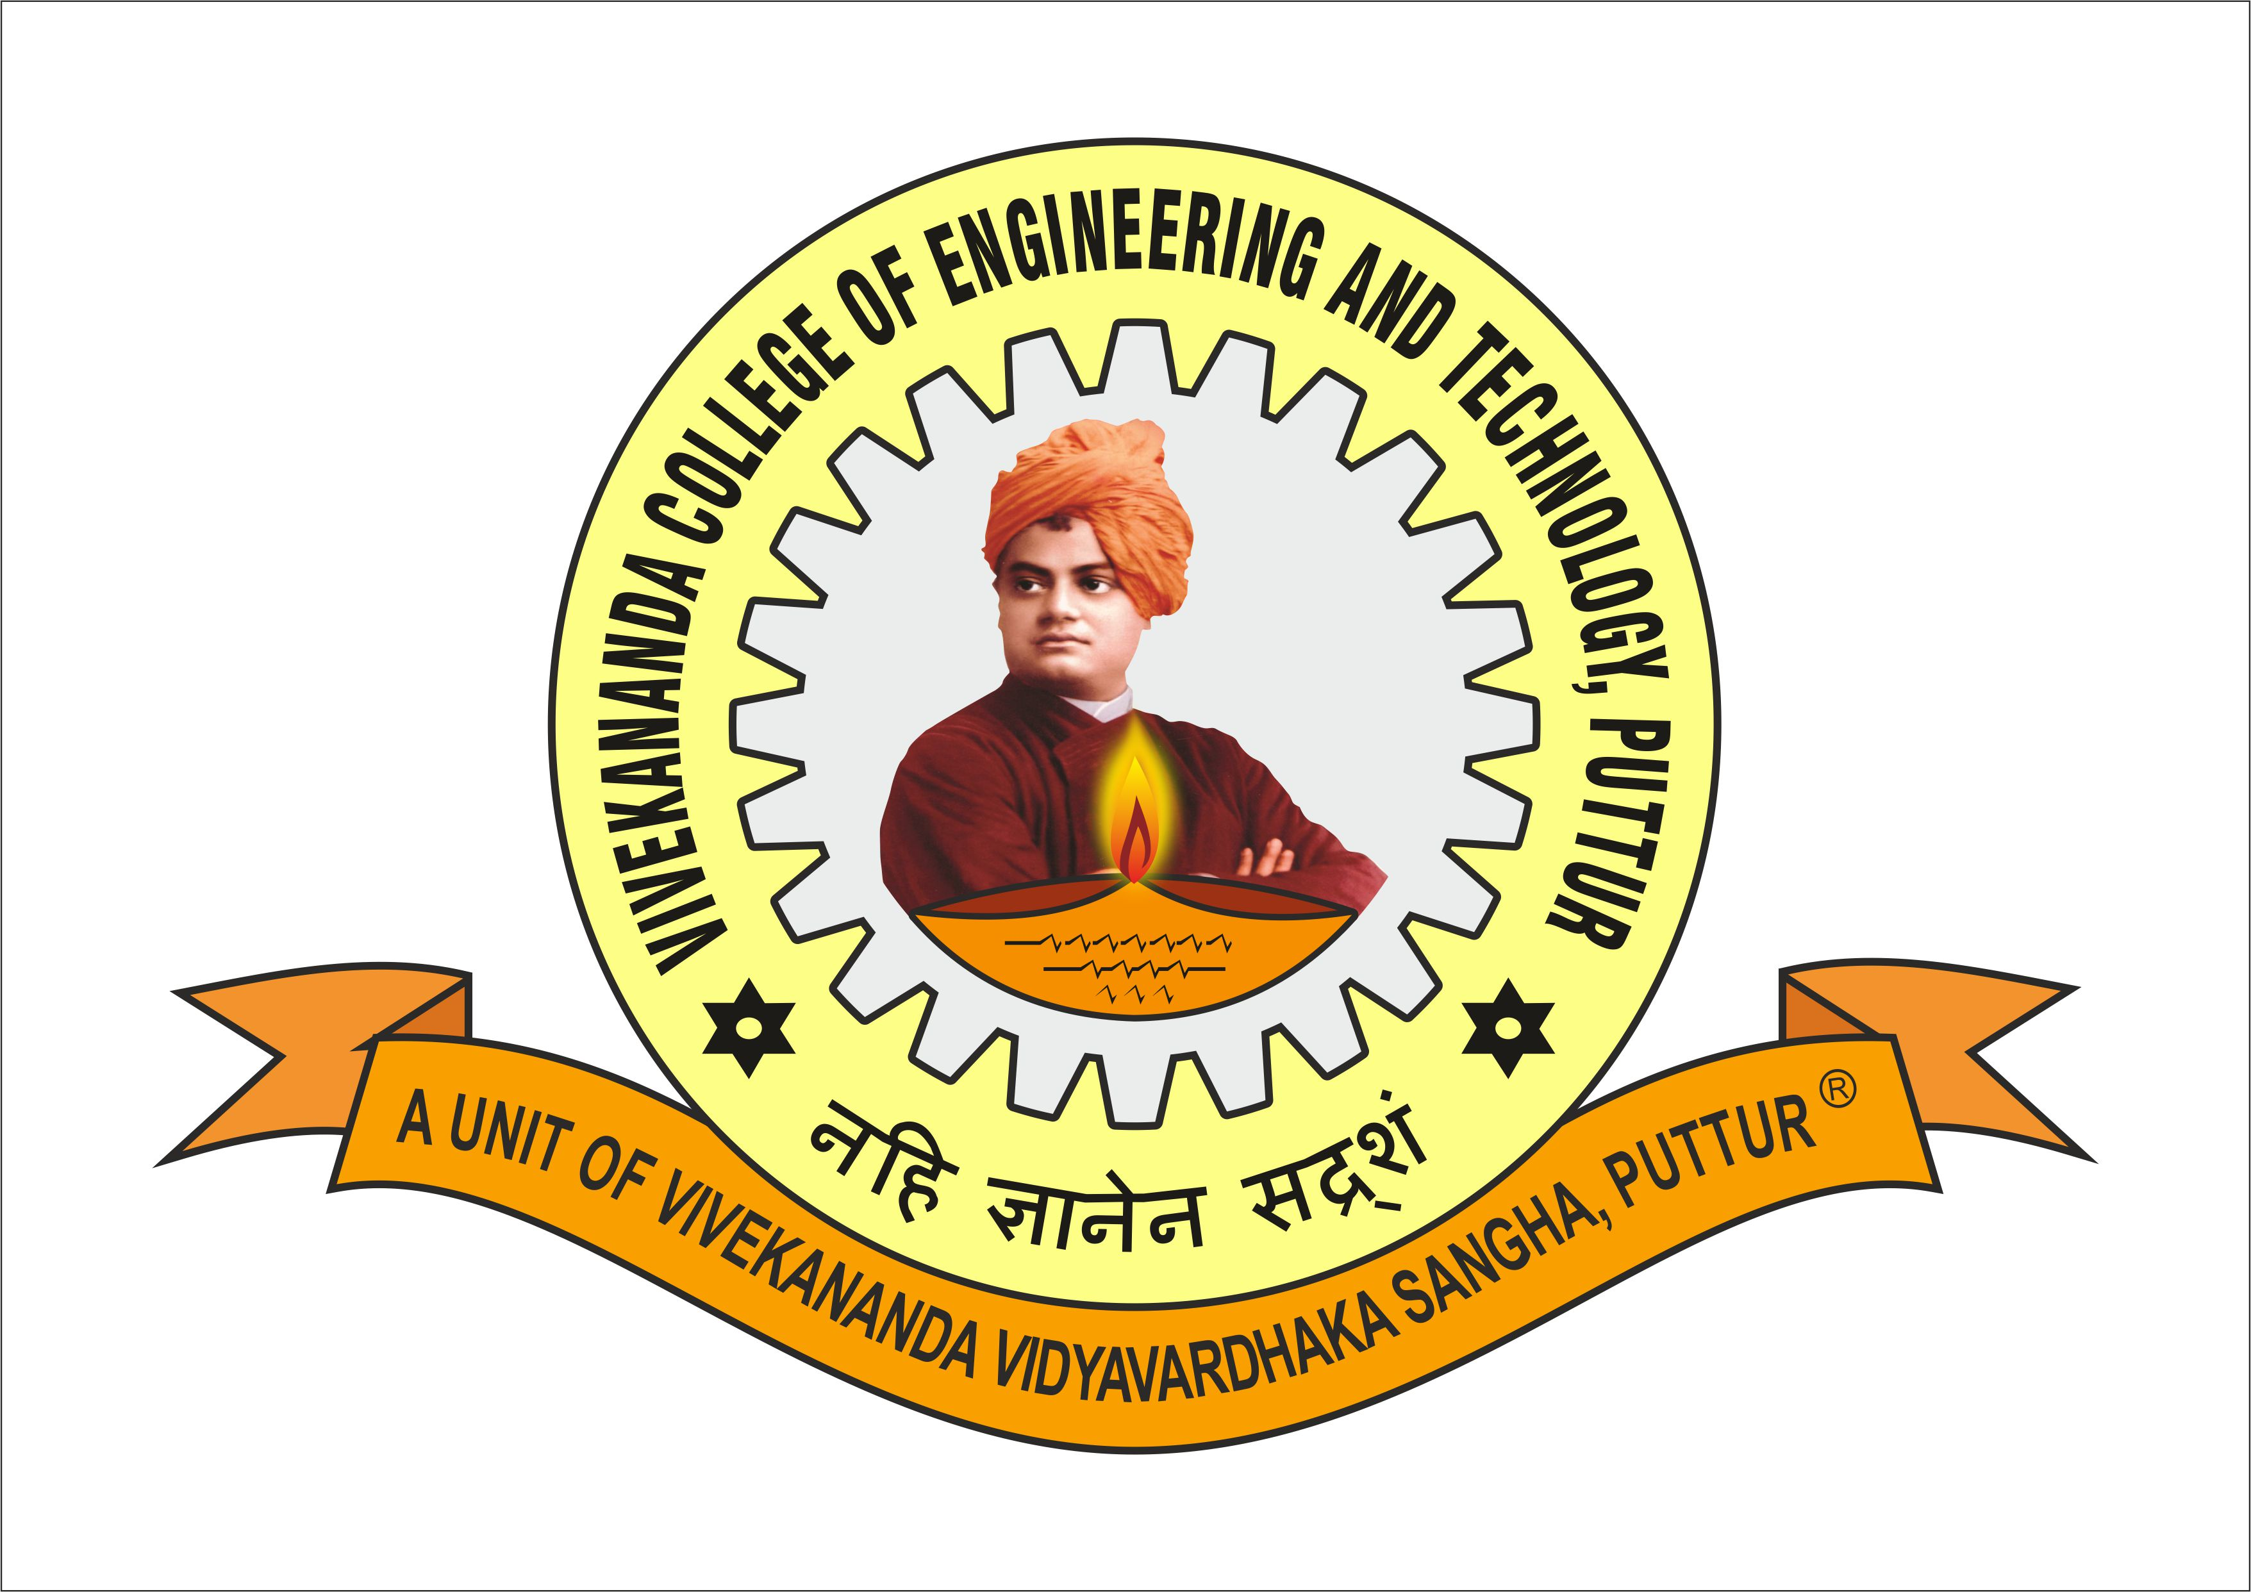

CERTIFICATE

Certified that the project work entitled ‘EXPENSE TRACKING USING PYTHON’ carried out by SAJITH THOMAS, 4VP21MC038 and GEETHANJALI, 4VP21MC014 a bonafide student of VIVEKANANDA COLLEGE OF ENGINEERING AND TECHNOLOGY, in partial fulfillment for the award of MASTER OF COMPUTER APPLICATIONS of the VISVESVARAYA TECHNOLOGICAL UNIVERSITY, BELAGAVI during the year 2022-23. The project has been approved as it satisfies the academic requirements in respect of Mini-Project work prescribed for the 3rd Semester Data Analytics Lab with Mini – Project (20MCA36) in Master of Computer Applications Degree.

Dr. Vandana B S
(Director - MCA)

Name of the Examiners: Signature with date

- ________________________ _ _ _ _ _ _ _ _ _ _ _ _ _ _

- ________________________ _ _ _ _ _ _ _ _ _ _ _ _ _ _

